Catching Zachytavadlo

Do Zachytavadla jdou vsechny hlavni stanice. Vedlejsi stanice projizdi VideoMatching. V Zachytavadle mame processing, preprocessing a inproceessing.

**Splitnuta hodina** – Zachytavadlo, kdyz je vypadek ve vysilani, vysilaci hodina se rozdeli na dva samostatne streamy. V Zachytavadle maji streamy delku 1h 15min, z duvodu presahu reklam pres celou hodinu. Pokud je vypadek v presahujicich minutach muze se splitnuty stream tvarit jako ze patri do nasledujici hodiny. Na zjisteni splitnute hodiny slouzi software **TvStorageManager**. Streamy se drzi na TvStorage max dva tydny.

i:\Software\OTHER\TvStorage2Manager.ClickOnce\Production\TvStorage2Manager_CZ.application

**Shift** – je posun videa proti casu ve ktery ho odvysilala televize.

**MatchingDefinition** – nastaveni ve Spravovadle, ktere kanaly - stanice (televize) jdou do Zachytavadla

**Reprocessing** – jelikoz nejdou vsechny hodiny do Z. (jdou tam jen hlavni stanice) tak vsechny hodiny holky nevidi. Kdyz strihnou novou reklamu a videoMatching uz projel nektere hodiny, tak je potreba, aby ty hodiny projel znova jen proti ty strihnuty norme.

**Inprocessing –** kdyz holka strihne na zacatku streamu reklamu, je potreba, aby se ji dostrihla na konci streamu. Takze se ji projedou i nasledujici dva streamy

**Preprocessing -**  kdyz holka otevre stream tak chce, aby se ji videoMatching podival na ten stream, jestli tam neni nejaky otevreny reprocessing. Ten by se vyridil prednostne pro tu hodinu. .

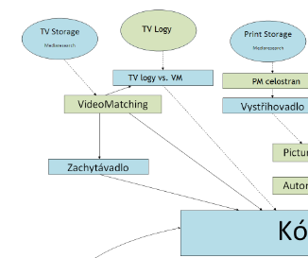

**Casova osa** – TimeLine se sklada z nekolika casti

Cast streamu kterou mam Cast streamu kterou nemam (Split)



Aktualne zobrazeny casovy usek (Vidim obrazky) Vystrihnuta reklama

Streamy dela automat z grabu. Lezi na TvStorage. Do MediaData3 se dostanou do tabulky [Creative].[VideoProcess]

V tabulce VideoProcess mame sloupce: [VideoLength] - delka streamu (dobre u splitu)

[VideoDateTime] – ze kdy je stream

[TvStorageChanelId] – z jakeho programu je stream

[TvStorageOutputRequestId] – vede na TvStorage.OutputRequest. Takhle se da najit stream primo na TVStorage

# Shift

Presny cas ktery je u me na hodinach je ten shiftnuty napr televize vysila zpravy a ukazuje 19:30 presne. Ve skutecnosti je uz 19:30:05 protoze 5 sekund trvalo, nez se signal dostal na moji televizi. Televize ukazuje mene

[‎03.‎12.‎2018 12:49]  Peter Hlavenka:

Prosim Te, proc je v Zachytavadle Shift ? Uz mi to P.Holubec jednou vysvetloval ale nepamatuju si to. Souvisi to s televizema, je to nejaka prodleva mezi ..... nevim cim.  Televize to nekde deklaruji kolik ten shift bude?

[‎03.‎12.‎2018 12:51]  Karel Honzl:

**Je to posin vysilani oproti realnemu casu. Za dob analogoveho vysilani to nebylo, ale kdyz prislo DVBT, tak jim trva nekolik vterin, nez ten signal zkomprimuji.** Takde kdyz pak ukazuji ve visilani hodiny, tak jsou oproti tvym hodinam posunuty.

vysilani, grr

[‎03.‎12.‎2018 12:52]  Peter Hlavenka:

Takze presny cas kdyz zacinaji v pul osme zpravy neni az tak presny :D

[‎03.‎12.‎2018 12:53]  Karel Honzl:

Jenze oni v deklaracich porad tvrdi, ze Televizni noviny zacinaji presne v 19:30. Pritom to neni pravda. K divakovi se dostanou o par vterin pozdeji...

presne tak

[‎03.‎12.‎2018 12:53]  Peter Hlavenka:

a jak se my dozvime kolik ten shift je ?

[‎03.‎12.‎2018 12:55]  Karel Honzl:

Bud tak, ze si to zkontrolujeme prave podle nejakych hodin ve vysilani nebo podle deklaraci, ktere nam TV posila. Pokud tvrdi, ze vsechny porady odvysilali o 3 vteriny drive, nez je mame my ve streamech, tak nastavim posin 3 vtresiny...

[‎03.‎12.‎2018 12:55]  Peter Hlavenka:

ok rozumim , dekuju

jeste jak casto se meni shift a kdo to nastavuje?

[‎03.‎12.‎2018 12:56]  Karel Honzl:

Takze v CZ je to clekem easy. TV nam psilaji deklarace a kdyz si nekdo vsimne, ze to nesedi, tak to dorovname, ale v BG zadne deklarace nemame (nebo ne tak presne), takze tam musi nekdou jednou za cas jit a zkusit dohledat nejake ty hodiny ve vysilani.

[‎03.‎12.‎2018 12:57]  Karel Honzl:

Neni nastaven (nebo alespon za me nebyl) zadny pravidelny process, kterym by se to kontrolovalo. Spis se to deje nahodne, kdyz si nekdo neceho vsimne.

Nastavuje se to ve Spravovadle v zalozce Sprava Medii.

# Nahled

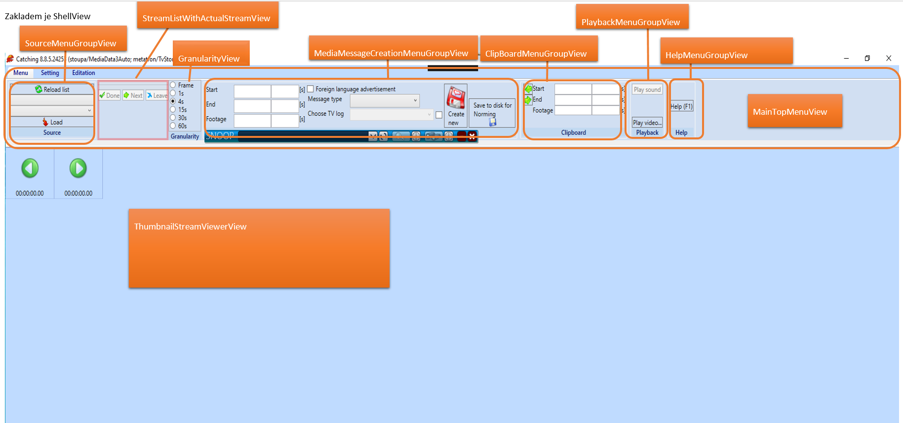

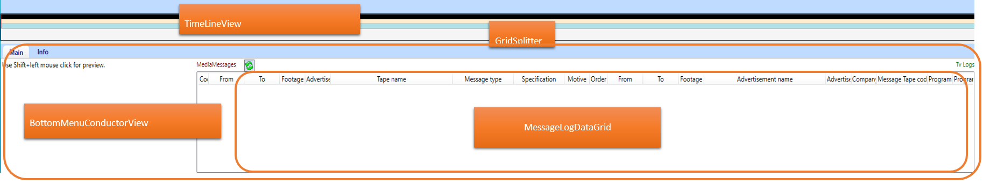

# Splitnuta hodina, Nalezeni splitnute hodiny pomoci TvStorageManagera

**Splitnuta hodina** – Zachytavadlo, kdyz je vypadek ve vysilani, vysilaci hodina se rozdeli na dva samostatne streamy. V Zachytavadle maji streamy delku 1h 15min, z duvodu presahu reklam pres celou hodinu. Pokud je vypadek v presahujicich minutach muze se splitnuty stream tvarit jako ze patri do nasledujici hodiny. Na zjisteni splitnute hodiny slouzi software TvStorageManager. Nastavim location Praha, multimedia type na Video a datum. Streamy se drzi na TvStorage max dva tydny.

i:\Software\OTHER\TvStorage2Manager.ClickOnce\Production\TvStorage2Manager_CZ.application

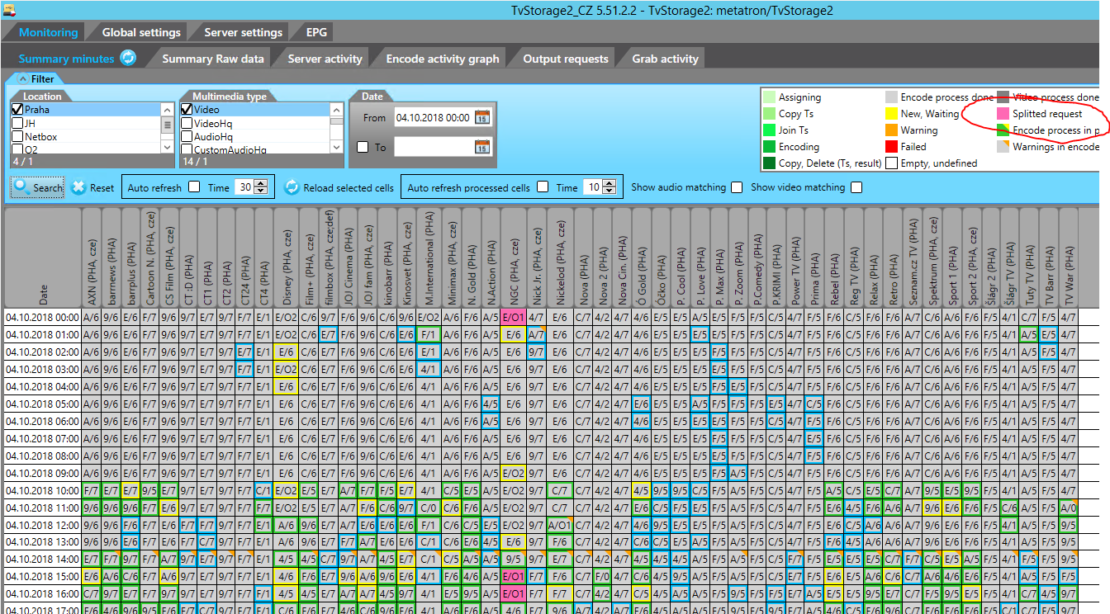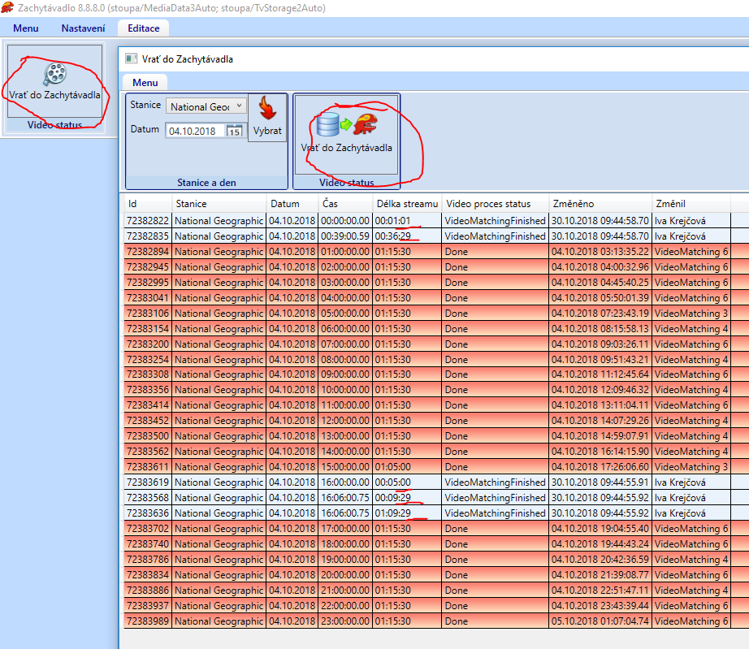

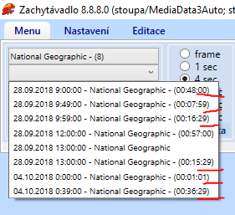

Nacetl jsem hodinu ktera zacina v 0:39:00 . Granularita je po minute, cerna cast na TimeLine ukazuje co chybi. Proto se tam neda skocit kliknutim na timelinu. Oranzova cast ukazuje zobrazeny usek, kdyz zmenim granularitu na treba 4s bude zobrazeny mensi usek streamu. Ted je videt od 39 minuty az do konce.

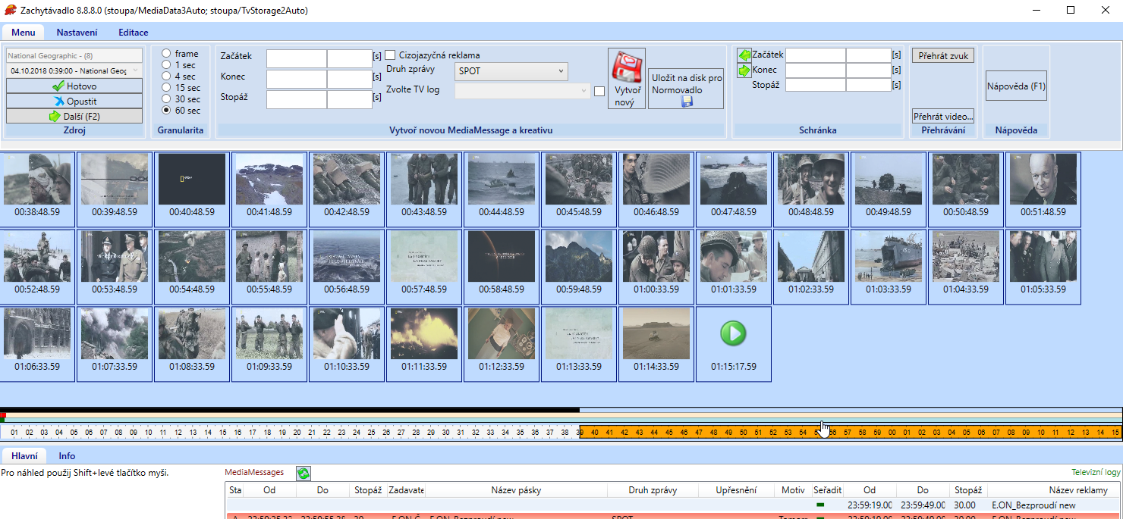

# Jak najit stream (Prenasi se poloha na casove ose do dalsiho streamu (split))

Hash **b02fe7f61e6b88f4fdf8d69d2eda9461e8dd18c8**

Prostředí **CZ test**

**Kroky:**

1. Jako první si načtu stream celé hodiny: https://i.gyazo.com/9fa2fc44a9128cdce458a685cd1e3a3a.png

2. Polohu na časové ose nechám někde uprostřed: <https://gyazo.com/3015b27d0e78786286c0d4e6038cb756>

3. Načtu si následující stream: https://i.gyazo.com/6a8ad5e66fcc9e30dcb2e1201053f995.png

4. Přenesená poloha je v "černé" oblasti: <https://gyazo.com/a9007fb616c00e49372f83dc14e4c282>

5. Kliknu dopředu na časovou osu a zobrazí se chyba: https://i.gyazo.com/72ea9c31bcfa7ebc40dee12f133b43e9.png

**Požadované chování:**

Po načtení split streamu se načtou framy od začátku "normálně zpracované" oblasti. Pozice na časové ose se nebude přenášet z předchozího streamu.

Mam tedy dany cas z bodu 1.

Kouknu do TVStorage manageru a vidim split ne v 13. Hodine ale ve 12. Podle Length[ms] vidime, ze mame pro dvanactou (trinactou) hodinu stream ktery ma celou pozadovanou delku 1h, 15 minut. Ten failnul a pro stejnou hodinu tam mame jeste dva dalsi streamy. Ten prvni je v pohode, to je cast kterou opravdu mame z teto hodiny. Dalsi je dostrizenych zbyvajicich 15 minut ktere presahuji. Tim, ze ale zacina az ve 13:00 se tvari jako ze patri do dalsi hodiny.

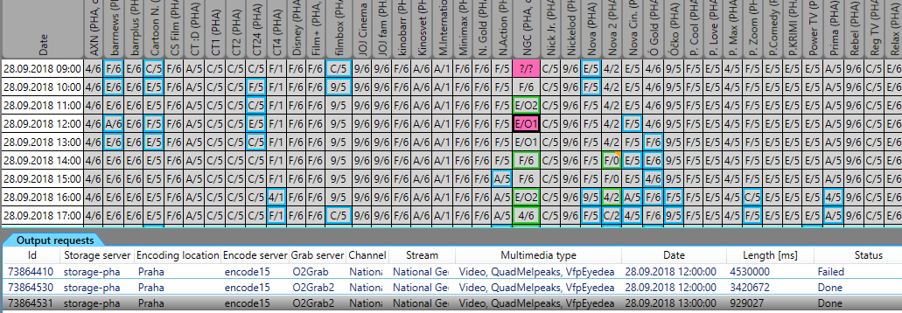

Otevru Zachytavadlo, dam si vrati hodinu a vidim, ze ve dvanactej hodine mam stream, ktery ma 57 minut. Nasleduje normalni cely stream pro 13. hodinu a hned za nim je dostrizeny zbytek dvanactej hodiny. Protoze se vsak dostrihl jen presah pres celou hodinu, zbytek zacina az ve 13:00:00:97 coz je matouci a tvari se to jako stream, ktery patri do 13. hodiny.

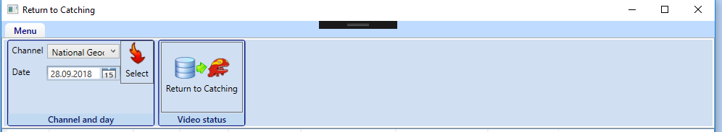

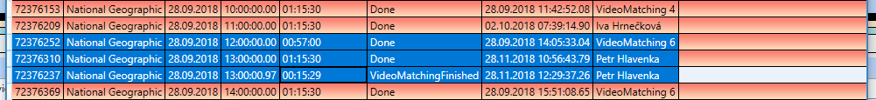

Kdyz chci najit Stream pro NationalGeographic NGC ze trinacte hodiny v MediaData databazi, chci nejaky proces z tabulky **Creative.VideoProcess**. Abych ho mohl identifikovat musim ho najoinovat na dalsi tabulky. Znam cas ze ktereho je ten process a kanal na kterem bezel. Potrebuju najoinovat tabulku Media.MediumVersion, kde je name programu. Joinuju proto tabulku Media.TvMedium, pres kterou se dostanu k tabulce kde najdu Name programu.

**Zjistim TvStorageChanelId:**

select * from Media.TvMedium tvm

join Media.MediumVersion mv on tvm.Id = mv.MediumId where name = 'National Geographic Channel'

**Najdu VideoProcess ktery ma moje TvStorageChanelId, tim dostanu TvStorageOutputRequestId:**

select top (1000)* from [Creative].[VideoProcess] where [VideoDateTime] > '20180928 13:00:00' and [VideoDateTime] < '20180928 13:00:01' and TvStorageChannelId = 41

**Prejdu na databazi TVStorage2 a vyhledam stream podle meho OutputRequest:**

select * from [dbo].[OutputRequest] where Id = 73864531

**Nalezeni splitu:**

select * from [Creative].[VideoProcess] vp

join Media.TvMedium tvm on vp.TvStorageChannelId = tvm.TvStorageChannelId

join Media.MediumVersion mv on tvm.Id = mv.MediumId where

[VideoLength] < 4530000 and [VideoDateTime] > '20181120'

# Zadani: kontrola delky vystrihu AdvertisementType

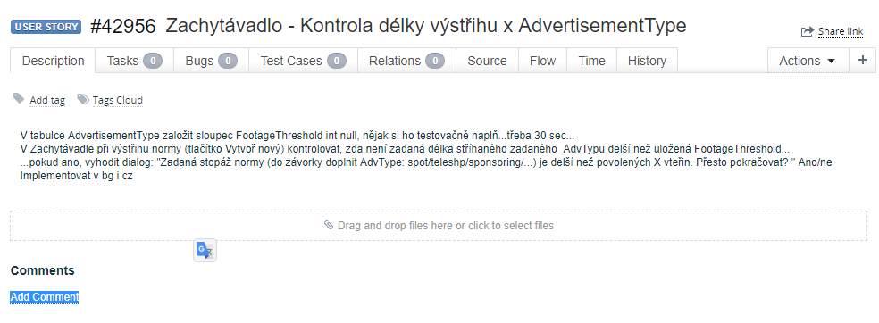

Nejprve je potreba mit nastaveny prava na zachytavadlo. Bez nich neni v aplikaci tlacitko Create new a Save

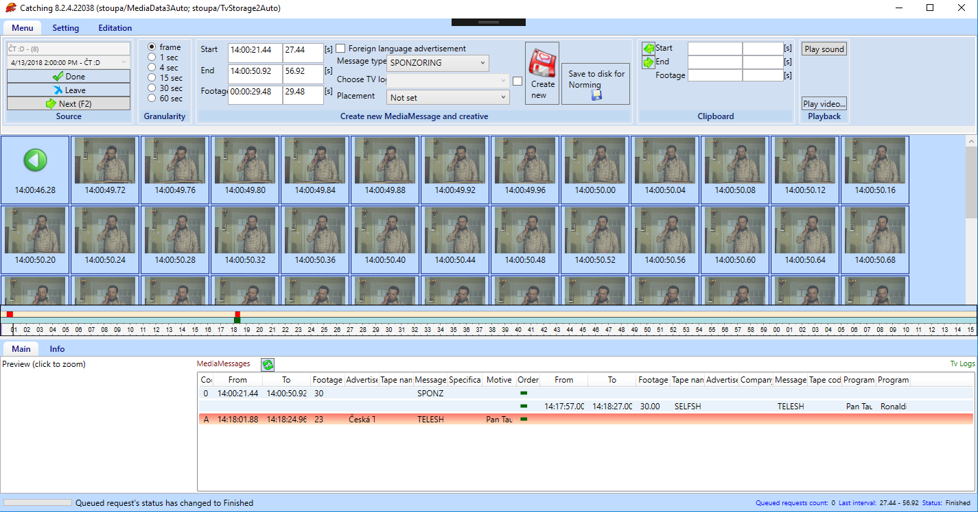

Pridani prav se da udelat v aplikaci Admin tak ze vyberu aplikaci kterou chci upravovat a UserPermission najdu sebe. Pak zmacknu copyFrom a vyberu uzivatele jehoz prava si chci pridat.



Oznaceni normy funguje nasledujicim zpusobem jen kdyz je radiobutton nastaven na frame 

Zacatek normy se oznaci CTRL + prave tlacitko mysi (LTM)

Muzu si prepnout granularitu na vice sekund, posunu si stream tak abych prekrocil min hranici delky MM

Prepnu znovu granularitu na frame

Konec normy se oznaci AltGr + LTM

**Help**

* **F1** -Show help
* **ESC** -Hide help

**Stream finishing**

* **F2** -Set stream to Done status and load next stream from queue

**Stream navigation**

* **Ctrl + left arrow key** -Move to previous frames
* **Ctrl + right arrow key** -Move to next frames
* **Left mouse click** -Decrease granularity
* **Right mouse click** -Increase granularity
* **Time line click** -Move stream to selected time

**New MediaMessage creation**

* **Ctrl + left mouse click** -Set start time of MediaMessage
* **Alt + left mouse click** -Set end time of MediaMessage

**Preview**

* **Shift + left mouse click** -Show preview of the frame
* **Left mouse click on preview** -Show full quality preview of the frame

**MediaMessages table**

* **Double click on any row** -Move stream to beginning of the MediaMessage
* **Right mouse click on any row** -Show context menu

Hodnoty se pridaji do textboxu :

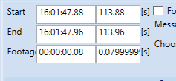

Do tabulky Media.AdvertisementType jsem pridal sloupec FootageThreshold

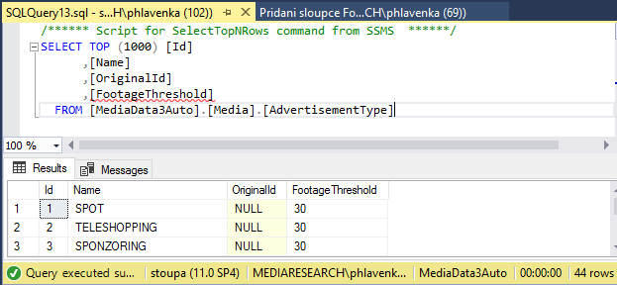

Pri vystrihavani normy se ma zachytavadlo podivat jakou hodnotu ma nastavenou pro zadany MessageType a podle toho jestli je prekrocena vyhodit dialog.

Nastavim teda pocatecni a koncovy cas a zmacknu tlacitko Create new.

Zadne okno nevyleze, jen dole vlevo se zobrazi progressBar a pise, ze tvori creativu.

V okne MediaMessages pribyde moje vystrihnuta norma .

Na tlacitko Save to disk se nejspis uklada ;D

Pomoci LiveVisualTree se pres tlacitko Create new dostanu do MediaMessageCreationMenuGroupView a dale do MediaMessageCreationMenuGroupViewModelu do metody CreateNewMessage()

# ChangeScript Pridani sloupce Threshold

/*

Author: Peter Hlavenka

Created: 25.4.2018

Description: #42957 Pridani sloupce Threshold

*/

set transaction isolation level serializable;

begin transaction updateSchemaTransaction;

begin try

/*

Kontrola aktuální verze schématu databáze

*/

declare @newDbSchemaVersion int;

select @newDbSchemaVersion = 137

declare @Location varchar(max);

select @Location = [Value] from [dbo].[Params] where [Name] = 'Location'

if (@Location is null)

raiserror('@Location is unknown.', 11, 11 )

ALTER TABLE [Media].[AdvertisementType] ADD [FootageThreshold] INT NULL

insert into dbo.[DbSchemaVersion] ( [DbSchemaVersion], [Created], [Modified])

values (@newDbSchemaVersion, getdate(), null)

commit transaction updateSchemaTransaction;

end try

begin catch

rollback transaction updateSchemaTransaction;

declare @ErrorMessage nvarchar (4000), @ErrorSeverity int, @ErrorState int;

select @ErrorMessage = ERROR_MESSAGE (), @ErrorSeverity = ERROR_SEVERITY (), @ErrorState = ERROR_STATE ();

raiserror (@ErrorMessage, @ErrorSeverity, @ErrorState);

end catch

GO

declare @ErrorSave int, @ModifiedBy int, @Modified datetime;

select @ModifiedBy = Security.GetUserId(), @Modified = getdate();

GO

begin tran

UPDATE [Media].[AdvertisementType] SET [FootageThreshold] = 30

commit tran

# Zadani: Analyza query Holubec

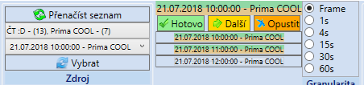

Na tlacitko Vybrat se nactou streamy a do spodniho gridu se nactou message. Je to pomale

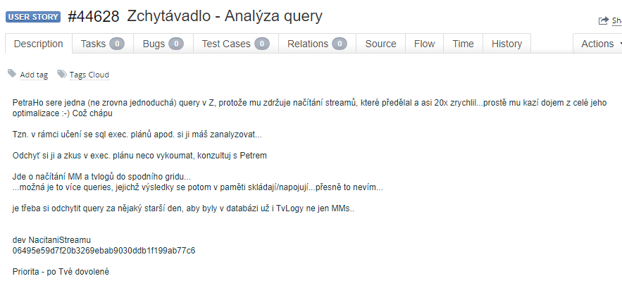

Tlacitko vybrat me dostane do SourceMenuGroupViewModel.Confirm()

Metody se zde volaji pomoci EventAggregatoru. Dostanu se do StreamListWithActualStreamViewModel. Handle(StreamListSourceChangedContract message)

Nacitani probiha asynchronne v metode await ChangeActualStream(Streams.FirstOrDefault());

Skrze tuto metodu se dostaneme do TvAdvertisementControl.Handle(ActualStreamChangedContract message) kde je LoadAllowedTvAdvertisementTypes(… )

Tak touto cestou to neslo, zkusim stopovat grid s messagema

CzMainBottomMenuView. ExtendedListView

ItemsSource="{Binding MessageControl.MessageLogWrappers}"

Vypada to, ze by se do gridu mohly message a TvLogy nacitat zde (MainBottomMenuBase):

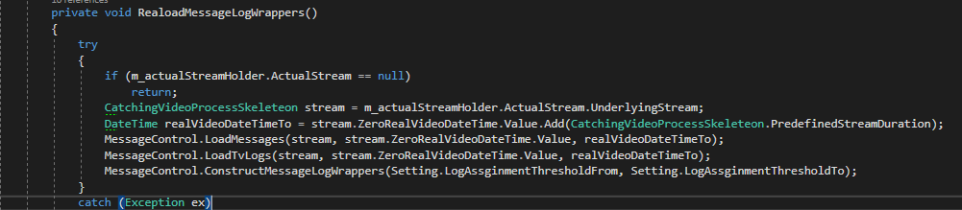

LoadMessages => tvMessageDao.GetTvMessagesCatching

LoadTvLogs => m_tvImportItemDao.GetTvLogs

m_broadcastingDescriptionDao.SelectByParams

m_intervalRemarkDao.SelectByParams

Chytam v profileru

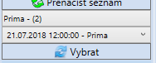

**tvMessageDao**.**GetTvMessagesCatching**

## SQL script

exec sp_executesql N'DECLARE @TempCatchingMessages TABLE(Id int, NormCreativeId INT, CreativeId INT, AdvertisedFrom DATETIME, AdvertisedTo DATETIME, CreatedBy TINYINT, ModifiedBy TINYINT, Footage SMALLINT, Modified DATETIME, MediumId SMALLINT, Medium NVARCHAR(255),

TapeCode VARCHAR(50), TapeName VARCHAR(100), PlacementId SMALLINT, Note VARCHAR(2000), ProgrammeBefore NVARCHAR(200), Motive varchar(500), ProgrammeAfter VARCHAR(200), AdvertisementTypeId TINYINT, UserCreatedByName VARCHAR(100),

UserModifiedByName VARCHAR(100), PlacementName VARCHAR(255), OwnerName NVARCHAR(200), AdvertisementTypeName NVARCHAR(255), CreativeItemId INT, CompanyBrand NVARCHAR(200), ProductBrand NVARCHAR(200), CodingPlausibility VARCHAR(25), MotiveId INT)

INSERT INTO @TempCatchingMessages (Id,NormCreativeId, CreativeId, AdvertisedFrom,AdvertisedTo, CreatedBy, ModifiedBy,Footage, Modified,

MediumId,Medium,TapeCode,TapeName,PlacementId,Note,ProgrammeBefore,Motive,ProgrammeAfter,AdvertisementTypeId,UserCreatedByName,

UserModifiedByName,PlacementName,OwnerName,AdvertisementTypeName,CreativeItemId,CompanyBrand,ProductBrand,CodingPlausibility,MotiveId)

SELECT mm.Id, mm.NormCreativeId, mm.CreativeId, mm.AdvertisedFrom, mm.AdvertisedTo, mm.CreatedBy, mm.ModifiedBy, tmm.Footage, mm.Modified, mm.MediumId, mdv.Name AS Medium, ti.TapeCode, ti.TapeName, mm.PlacementId, mm.Note, pbl.ProgrammeBefore, mv.Name AS Motive,

pbl.ProgrammeAfter, mm.AdvertisementTypeId, uc.UserName AS UserCreatedByName, um.UserName AS UserModifiedByName, p.Name AS PlacementName, o.Name AS OwnerName, at.Name AS AdvertisementTypeName, ctci.CreativeItemId, cb.Name AS CompanyBrand, pb.Name AS ProductBrand, cp.Name AS CodingPlausibility,

mv.MotiveId AS MotiveId

FROM Media.MediaMessage mm

INNER JOIN Media.TvMediaMessage tmm ON mm.Id = tmm.Id

INNER JOIN Media.Medium md ON mm.MediumId = md.Id

INNER JOIN Media.MediumVersion mdv ON md.Id = mdv.MediumId AND mdv.ActiveFrom <= mm.AdvertisedFrom AND mdv.ActiveTo > mm.AdvertisedFrom

INNER JOIN Media.CodingPlausibility cp ON mm.CodingPlausibilityId = cp.Id

LEFT JOIN Media.ProgrammeBlock pbl ON tmm.ProgrammeBlockId = pbl.Id

LEFT JOIN Media.TapeInfo ti ON tmm.TapeInfoId = ti.Id

LEFT JOIN Security.[User] uc ON mm.CreatedBy = uc.Id

LEFT JOIN Media.AdvertisementType at ON mm.AdvertisementTypeId = at.Id

LEFT JOIN Security.[User] um ON mm.ModifiedBy = um.Id

LEFT JOIN Media.Placement p ON mm.PlacementId = p.Id

LEFT JOIN Creative.Creative c ON mm.CreativeId = c.Id

LEFT JOIN Creative.CreativeToCreativeItem ctci ON ctci.CreativeId = c.Id

LEFT JOIN Media.Motive m ON m.Id = c.MotiveId

LEFT JOIN Media.MotiveVersion mv ON mv.MotiveId = m.Id AND mv.ActiveFrom <= @from AND mv.ActiveTo >= @to

LEFT JOIN Media.Motivlet ml ON mv.PrimaryMotivletId = ml.Id

LEFT JOIN Media.Owner o ON ml.OwnerId = o.Id

LEFT JOIN Media.CompanyBrand cb ON ml.CompanyBrandId = cb.Id

LEFT JOIN Media.ProductBrand pb ON ml.ProductBrandId = pb.Id

LEFT JOIN Media.SponsoredProgramme sp ON tmm.SponsoredProgrammeId = sp.Id

WHERE mm.AdvertisedFrom >= @fromHelper AND mm.AdvertisedFrom < @to AND mm.AdvertisedTo > @from AND mm.AdvertisedTo < @to

AND mm.MediumId IN (493)

;WITH A AS -- #42544 Nahraj pro kazdou MM TapeCode od normy. Vezme se TapeCode od nejstarsi zpravy normy

(

SELECT temp.*, ti2.TapeCode AS NormsTapeCode,

ROW_NUMBER() OVER (PARTITION BY mm2.NormCreativeId, temp.Id ORDER BY mm2.Created) AS RN

FROM @TempCatchingMessages temp

JOIN Media.MediaMessage mm2 ON mm2.NormCreativeId = temp.NormCreativeId

JOIN Media.TvMediaMessage tmm2 ON mm2.Id = tmm2.Id

LEFT JOIN Media.TapeInfo ti2 ON tmm2.TapeInfoId = ti2.Id

)

SELECT * FROM A WHERE a.RN = 1',N'@from datetime,@to datetime,@fromHelper datetime',@from='2018-07-21 11:59:53.600',@to='2018-07-21 13:15:23.600',@fromHelper='2018-07-21 10:59:53.600'

## Po odchyceni scriptu

V profileru vidim, ze Duration bylo 2410 ms.



Vlozim do ManagmentStudia, spustim se zapnutym actual plan

Vidim, ze mam dva dotazy.

V prvnim vidim velkou pipe na tabulce Media.MediumVersion. Precte tu 75 000 radku protoze je zde index scan . Chceme zde totiz :

INNER JOIN Media.MediumVersion mdv ON md.Id = mdv.MediumId AND mdv.ActiveFrom <= mm.AdvertisedFrom AND mdv.ActiveTo > mm.AdvertisedFrom

Na AdvertisedFrom a To neni index, nejsem si jisty, jestli davat index nad DateTime sloupce. Zbytek planu se zda byt v poradku, vsude jsou indexy a cost se pohybuje kolem 3%.

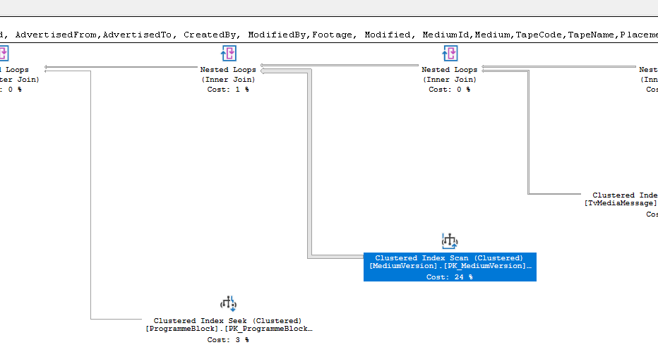

Druhy dotaz ma sice Table Scan ale to je proto, ze hledame hodnoty pro kazdy radek tempTabulky a jinak jsou vsude indexy. Zajimave je, ze estimated number of rows je 1 a actual = 105 000

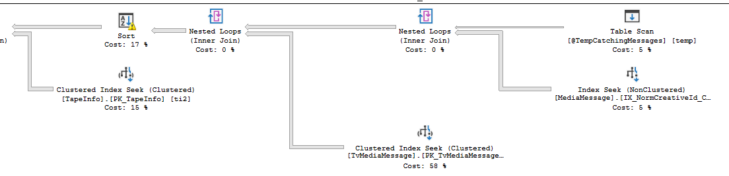

**m_tvImportItemDao.GetTvLogs**

## script

exec sp_executesql N'SELECT

[tvImportItem].[ImportId],

[tvImportItem].[ModificationStatusId],

[tvImportItem].[OriginalImportItemId],

[tvImportItem].[MediaMessageId],

[tvImportItem].[AdvertisementTypeId],

[tvImportItem].[AdvertisedFrom],

[tvImportItem].[AdvertisedTo],

[tvImportItem].[MediumId],

[tvImportItem].[Footage],

[tvImportItem].[AdvertisementName],

[tvImportItem].[AdvertiserName],

[tvImportItem].[AgencyName],

[tvImportItem].[CompanyBrandName],

[tvImportItem].[ProductCode],

[tvImportItem].[ProductName],

[tvImportItem].[BlockCode],

[tvImportItem].[BlockEnd],

[tvImportItem].[BlockPosition],

[tvImportItem].[BlockRating],

[tvImportItem].[BlockStart],

[tvImportItem].[BlockUnits],

[tvImportItem].[PoolingIdentifier],

[tvImportItem].[ProgrammeAfter],

[tvImportItem].[ProgrammeBefore],

[tvImportItem].[ProgrammeTypeAfter],

[tvImportItem].[ProgrammeTypeBefore],

[tvImportItem].[ProgrammeTypeAfterCode],

[tvImportItem].[ProgrammeTypeBeforeCode],

[tvImportItem].[TapeCode],

[tvImportItem].[TapeLength],

[tvImportItem].[TapeName],

[tvImportItem].[TapeAgencyName],

[tvImportItem].[Rating],

[tvImportItem].[Created],

[tvImportItem].[CreatedBy],

[tvImportItem].[Modified],

[tvImportItem].[ModifiedBy],

[tvImportItem].[BlockIdent],

[tvImportItem].[Note],

[tvImportItem].[Id],

[t1].[Name],

[t1].[OriginalId],

[t1].[FootageThreshold],

[t1].[Id] as [Id1]

FROM

[Import].[TvImportItem] [tvImportItem]

INNER JOIN [Media].[AdvertisementType] [t1] ON [tvImportItem].[AdvertisementTypeId] = [t1].[Id]

INNER JOIN [Media].[Medium] [medium] ON [tvImportItem].[MediumId] = [medium].[OriginalId]

WHERE

[tvImportItem].[AdvertisedFrom] > @boundary AND

Convert(Int, [tvImportItem].[AdvertisementTypeId]) <> 4 AND

[tvImportItem].[AdvertisedTo] > @p1 AND

[tvImportItem].[AdvertisedFrom] < @dateTimeTo AND

[medium].[Id] IN (493)

ORDER BY

[tvImportItem].[AdvertisedFrom]

',N'@boundary datetime,@p1 datetime,@dateTimeTo datetime',@boundary='2018-07-21 10:59:53.600',@p1='2018-07-21 11:59:53.600',@dateTimeTo='2018-07-21 13:15:23.600'

## Pokr

Pro toto medium mi nevratilo zadne radky (tvImportItem) mozna proto, ze pro medium nejsou zadne TvLogy ? Ano!

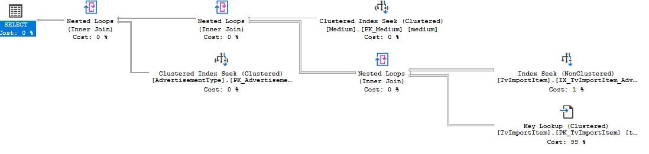

**m_broadcastingDescriptionDao.SelectByParams**

## script

exec sp_executesql N'SELECT TOP (2147483647)

[broadcastingDescr].[LevelId],

[broadcastingDescr].[MediumId],

[broadcastingDescr].[DateTimeFrom],

[broadcastingDescr].[DateTimeTo],

[broadcastingDescr].[ProgrammeId],

[broadcastingDescr].[ParentId],

[broadcastingDescr].[Created],

[broadcastingDescr].[CreatedBy],

[broadcastingDescr].[Modified],

[broadcastingDescr].[ModifiedBy],

[broadcastingDescr].[Id],

[programme].[PrgTypeId],

[programme].[AttributeId],

[programme].[Created] as [Created1],

[programme].[CreatedBy] as [CreatedBy1],

[programme].[Modified] as [Modified1],

[programme].[ModifiedBy] as [ModifiedBy1],

[programme].[Name],

[programme].[Id] as [Id1],

[t3].[Id] as [Id2],

[t3].[Local] as [Local1],

[t4].[ExternalId],

[t4].[Local] as [Local2],

[t4].[En],

[t4].[Id] as [Id3],

[t5].[Login],

[t5].[UserName],

[t5].[UserTypeId],

[t5].[Id] as [Id4],

[t6].[Login] as [Login1],

[t6].[UserName] as [UserName1],

[t6].[UserTypeId] as [UserTypeId1],

[t6].[Id] as [Id5],

[tran].[ProgrammeId] as [TranslatedEntityId],

[tran].[LocalizationLanguageId],

[tran].[Name] as [Name1],

[tran].[IsReviewed],

[tran].[Created] as [TranslationCreated],

[tran].[CreatedBy] as [TranslationCreatedBy],

[tran].[Modified] as [TranslationModified],

[tran].[ModifiedBy] as [TranslationModifiedBy],

[t1].[Login] as [Login2],

[t1].[UserName] as [UserName2],

[t1].[UserTypeId] as [UserTypeId2],

[t1].[Id] as [Id6],

[t2].[Login] as [Login3],

[t2].[UserName] as [UserName3],

[t2].[UserTypeId] as [UserTypeId3],

[t2].[Id] as [Id7],

[mv].[Name] as [Name2],

[mv].[PublisherId],

[mv].[MediumId] as [MediumId1],

[mv].[PressPeriodicityId],

[mv].[IsMinorChannel],

[mv].[TvlogShift],

[mv].[FocusId],

[mv].[ActiveFrom],

[mv].[ActiveTo],

[mv].[Created] as [Created2],

[mv].[CreatedBy] as [CreatedBy2],

[mv].[Modified] as [Modified2],

[mv].[ModifiedBy] as [ModifiedBy2],

[mv].[NoAggregationTargetGroupId],

[mv].[PageOfEar],

[mv].[Id] as [Id8]

FROM

[SimLog].[BroadcastingDescription] [broadcastingDescr]

INNER JOIN [Security].[User] [t1] ON [broadcastingDescr].[CreatedBy] = [t1].[Id]

LEFT JOIN [Security].[User] [t2] ON [broadcastingDescr].[ModifiedBy] = [t2].[Id]

INNER JOIN [SimLog].[Programme] [programme]

INNER JOIN [SimLog].[Attribute] [t3] ON [programme].[AttributeId] = [t3].[Id]

INNER JOIN [SimLog].[PrgType] [t4] ON [programme].[PrgTypeId] = [t4].[Id]

INNER JOIN [Security].[User] [t5] ON [programme].[CreatedBy] = [t5].[Id]

LEFT JOIN [Security].[User] [t6] ON [programme].[ModifiedBy] = [t6].[Id]

ON [broadcastingDescr].[ProgrammeId] = [programme].[Id]

INNER JOIN [Media].[MediumVersion] [mv] ON [broadcastingDescr].[MediumId] = [mv].[MediumId]

LEFT JOIN [SimLog].[ProgrammeTranslation] [tran] ON [programme].[Id] = [tran].[ProgrammeId]

WHERE

([tran].[LocalizationLanguageId] IS NULL AND [tran].[ProgrammeId] IS NULL OR [tran].[LocalizationLanguageId] = @localizationLanguageId1) AND

[mv].[ActiveFrom] <= [broadcastingDescr].[DateTimeFrom] AND

[mv].[ActiveTo] > [broadcastingDescr].[DateTimeFrom] AND

[broadcastingDescr].[DateTimeFrom] >= @from1 AND

[broadcastingDescr].[DateTimeFrom] < @to1 AND

[broadcastingDescr].[MediumId] IN (493)

ORDER BY

[broadcastingDescr].[DateTimeFrom] DESC

',N'@localizationLanguageId1 tinyint,@from1 datetime,@to1 datetime',@localizationLanguageId1=2,@from1='2018-07-21 11:59:53.600',@to1='2018-07-21 13:15:23.600'

## pokr

Opet je tu zajimavy index scan na tabulce MediumVersion

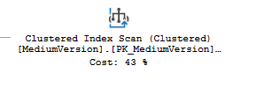

**m_intervalRemarkDao.SelectByParams**

## Script

exec sp_executesql N'SELECT

[x].[MediumId],

[x].[IntervalRemarkTypeId],

[x].[From] as [From1],

[x].[To] as [To1],

[x].[Created],

[x].[Modified],

[x].[CreatedBy],

[x].[ModifiedBy],

[x].[Id]

FROM

[SimLog].[IntervalRemark] [x]

WHERE

[x].[MediumId] = @p1 AND [x].[From] >= @dateTimeFrom AND

[x].[To] <= @dateTimeTo

',N'@p1 int,@dateTimeFrom datetime,@dateTimeTo datetime',@p1=493,@dateTimeFrom='2018-07-21 11:59:53.600',@dateTimeTo='2018-07-21 13:15:23.600'

## Pokr

Tady neni co resit

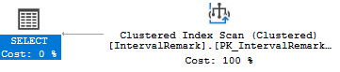

|  |  |
| --- | --- |
| Puvodni cas | Novy cas |
| 2597 | 1017 |
| 165 | 6 |
| 0 | 46 |
| 0 | 0 |

**Bez Indexu**

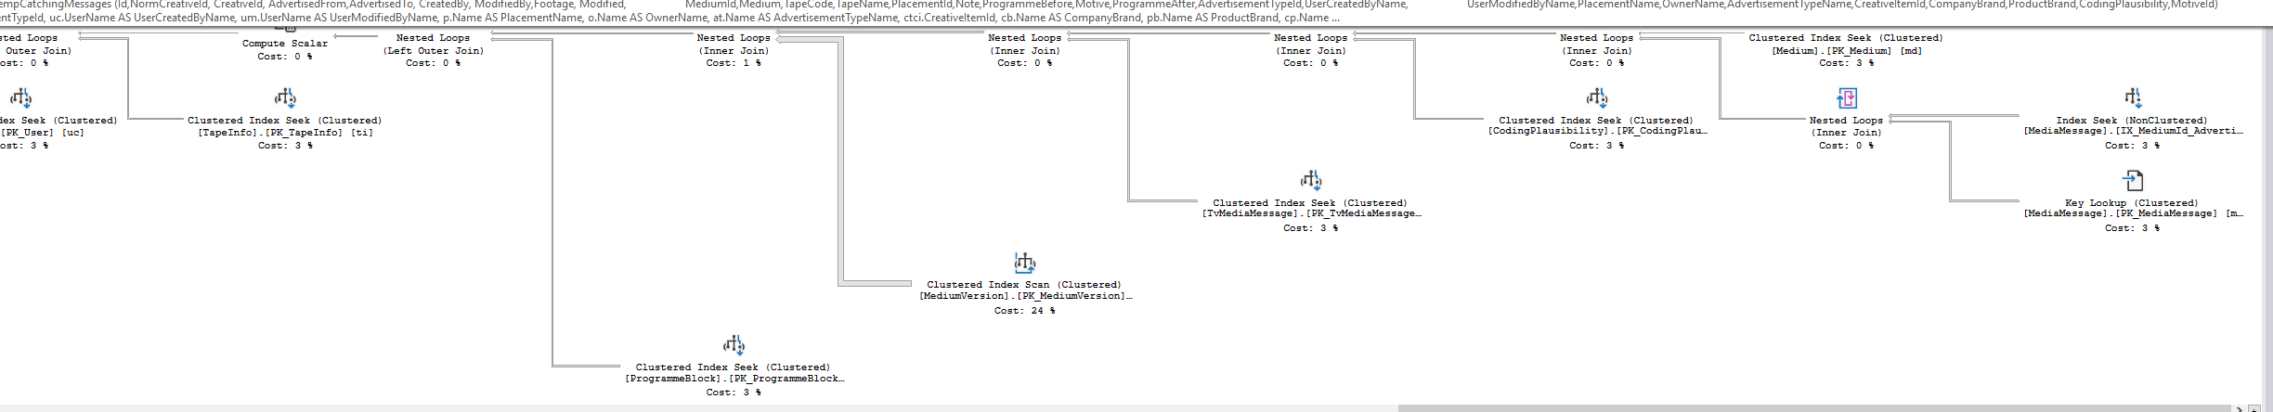

**S indexem :**

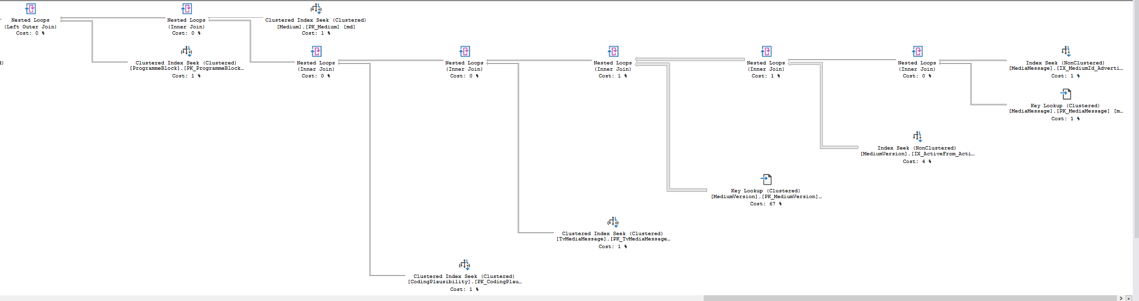

# Nejvice boli ready (cteni) , rozdeleni storovky na vice dotazu a postupne nacitani

**LoadMessages => tvMessageDao.GetTvMessagesCatching**

Cela odchycena query je v C:\Users\phlavenka\OneDrive\Nielsen prace\My Scripts\Zachytavadlo\Analyza query Holubec\Uz rozdelovani query

Trva nenacacheovana 21 sekund a jeji result je:

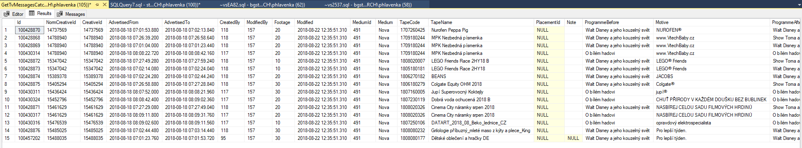

* **Vyberu z ni jen zakladni dotaz jak mi poradil Petr , vrati se mi toto**

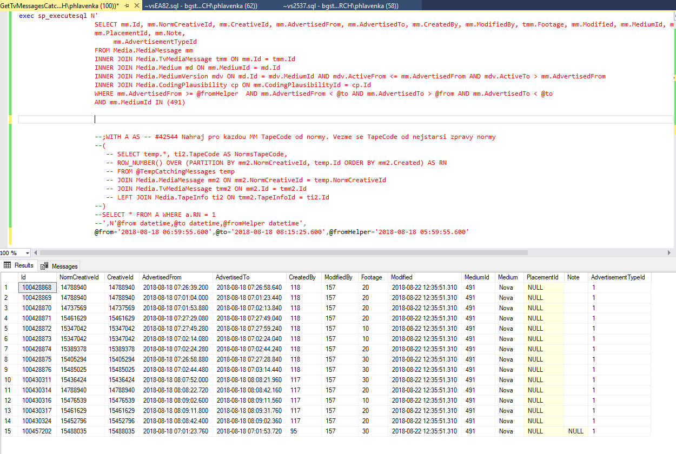

* Nejprve dostanu zaklad
* Potom prijoinuju zbytek
* Kolekci insertnu do temptabulky
* Spojim s cte a dostanu result

## pokr

**Spravna data od puvodni query: A data moji query:**

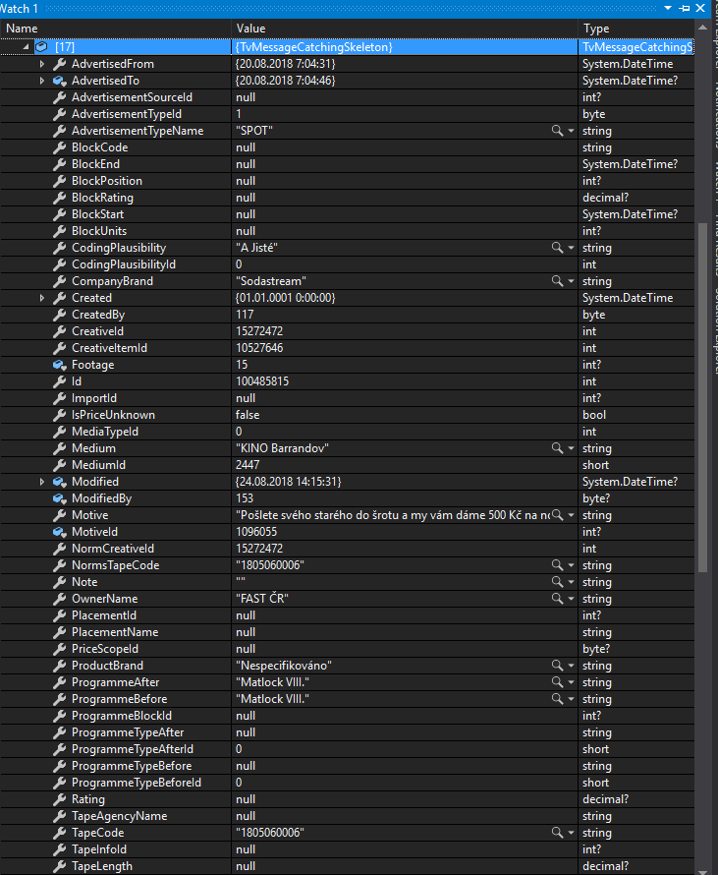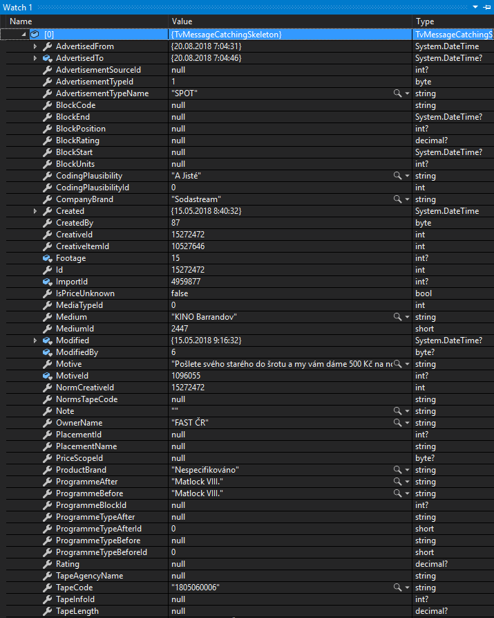

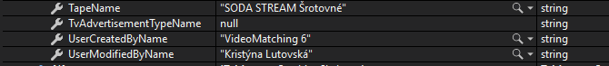

INSERT INTO ##TempCatchingMessages (Id,NormCreativeId, CreativeId, AdvertisedFrom,AdvertisedTo, CreatedBy, ModifiedBy,Footage, Modified,

MediumId,Medium,TapeCode,TapeName,PlacementId,Note,ProgrammeBefore,ProgrammeAfter,AdvertisementTypeId,UserCreatedByName,

UserModifiedByName,PlacementName,AdvertisementTypeName,CodingPlausibility)

SELECT mm.Id, mm.NormCreativeId, mm.CreativeId, mm.AdvertisedFrom, mm.AdvertisedTo, mm.CreatedBy, mm.ModifiedBy, tmm.Footage, mm.Modified,

mm.MediumId, mdv.Name AS Medium, ti.TapeCode, ti.TapeName, mm.PlacementId, mm.Note, pbl.ProgrammeBefore,

pbl.ProgrammeAfter, mm.AdvertisementTypeId, uc.UserName AS UserCreatedByName, um.UserName AS UserModifiedByName, p.Name AS PlacementName,

at.Name AS AdvertisementTypeName, cp.Name AS CodingPlausibility

FROM Media.MediaMessage mm

INNER JOIN Media.TvMediaMessage tmm ON mm.Id = tmm.Id

INNER JOIN Media.Medium md ON mm.MediumId = md.Id

INNER JOIN Media.MediumVersion mdv ON md.Id = mdv.MediumId AND mdv.ActiveFrom <= mm.AdvertisedFrom AND mdv.ActiveTo > mm.AdvertisedFrom

INNER JOIN Media.CodingPlausibility cp ON mm.CodingPlausibilityId = cp.Id

LEFT JOIN Media.ProgrammeBlock pbl ON tmm.ProgrammeBlockId = pbl.Id

LEFT JOIN Media.TapeInfo ti ON tmm.TapeInfoId = ti.Id

LEFT JOIN Security.[User] uc ON mm.CreatedBy = uc.Id

LEFT JOIN Media.AdvertisementType at ON mm.AdvertisementTypeId = at.Id

LEFT JOIN Security.[User] um ON mm.ModifiedBy = um.Id

LEFT JOIN Media.Placement p ON mm.PlacementId = p.Id

WHERE mm.AdvertisedFrom >= @fromHelper AND mm.AdvertisedFrom < @to AND mm.AdvertisedTo > @from AND mm.AdvertisedTo < @to

AND mm.MediumId IN ({0})

;WITH A AS -- #42544 Nahraj pro kazdou MM TapeCode od normy. Vezme se TapeCode od nejstarsi zpravy normy

(

SELECT temp.*, ti2.TapeCode AS NormsTapeCode,

ROW_NUMBER() OVER (PARTITION BY mm2.NormCreativeId, temp.Id ORDER BY mm2.Created) AS RN

FROM ##TempCatchingMessages temp

JOIN Media.MediaMessage mm2 ON mm2.NormCreativeId = temp.NormCreativeId

JOIN Media.TvMediaMessage tmm2 ON mm2.Id = tmm2.Id

LEFT JOIN Media.TapeInfo ti2 ON tmm2.TapeInfoId = ti2.Id

)

SELECT * FROM A WHERE a.RN = 1

## Proc v hotove query nesmi byt delete

Je popsano I s komentarem v sql scriptu

[..\My Scripts\Zachytavadlo\Analyza query Holubec\Uz rozdelovani query\Hotovy dotaz vse v jednom per session - Oprava bugu s komentarem.sql](../My%20Scripts/Zachytavadlo/Analyza%20query%20Holubec/Uz%20rozdelovani%20query/Hotovy%20dotaz%20vse%20v%20jednom%20per%20session%20-%20Oprava%20bugu%20s%20komentarem.sql)

# Zachytávadlo - Tlačítka Done a Next jsou aktivní i při načítání streamu

[#44788](https://tp.mediaresearch.cz/RestUI/Board.aspx?acid=6C17D8319C81AC3D36AFAD64CAE08A28&acid=6C17D8319C81AC3D36AFAD64CAE08A28#page=bug/44788&appConfig=eyJhY2lkIjoiNDRGMDk4QUQ1MDIzMThCMDQzODI4QTQ0OTU3OUI2RjkifQ==)

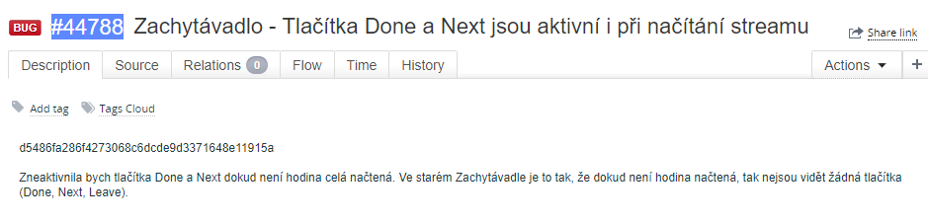

Po predelani streamu Holubcem pribyl v MainTopMenuView StreamListWithActualStreamView

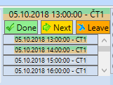

Cast dole je itemsControl, kde jednotlive radky predstavuji IVideoProcessWrapper. Mame ActualStream to je ten zobrazovany. Iva chce aby tlacitka byly aktivni az kdyz bude tento stream nacteny.

# Neprehrava stream od zacatku MM

**G**[#45291](https://tp.mediaresearch.cz/RestUI/Board.aspx?acid=6C17D8319C81AC3D36AFAD64CAE08A28&acid=6C17D8319C81AC3D36AFAD64CAE08A28#page=bug/45291&appConfig=eyJhY2lkIjoiNDRGMDk4QUQ1MDIzMThCMDQzODI4QTQ0OTU3OUI2RjkifQ==)

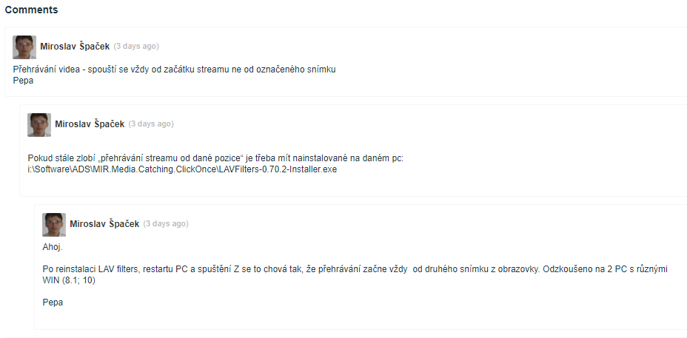

# Nefunguje prehrani zvuku

[#44830](https://tp.mediaresearch.cz/RestUI/Board.aspx?acid=6C17D8319C81AC3D36AFAD64CAE08A28&acid=6C17D8319C81AC3D36AFAD64CAE08A28#page=bug/44830&appConfig=eyJhY2lkIjoiNDRGMDk4QUQ1MDIzMThCMDQzODI4QTQ0OTU3OUI2RjkifQ==)

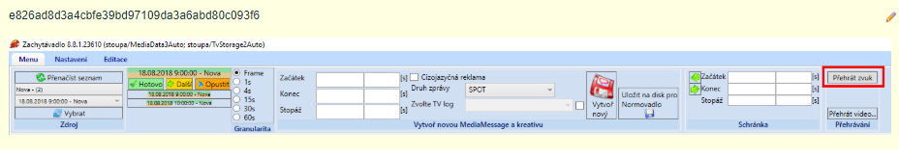

Kouknul jsem jak je to ve videoPlayeru, a nastavil jsem novy source (AudioPlayerViewModel). Pozor: aby bylo mozne nastavit pozici, musi byt prehrava playing (nejprve .Play(), pak pozici). U videoprehravace je zobrazovany cas posunuty. Je to z duvodu shiftu na vysilani.

public void Play()

{

try

{

var requestedStreamFile = m_fileStreamStorage.RequestStreamFile(new StreamFileRequest(ActualStreamHolder.ActualStream.VideoProcessId,

ActualStreamHolder.ActualStream.UnderlyingStream.TvStorageOutputRequestId.Value, int.MaxValue, CancellationToken.None)).GetAwaiter().GetResult();

Source = new Uri(requestedStreamFile.FileInfo.FullName, UriKind.Absolute);

m_view.soundElement.Play();

m_view.soundElement.Position = TimeSpan.FromSeconds((double)m_streamPositionProvider.GetActualPosition());

SetButtons(true);

}

catch (Exception ex)

{

if (m_log.IsErrorEnabled)

m_log.Error("Unable to play audio!", ex);

}

}

# Načítání streamů - Nezačne se načítat vybraný v comboboxu

[#45105](https://tp.mediaresearch.cz/RestUI/Board.aspx?acid=6C17D8319C81AC3D36AFAD64CAE08A28&acid=6C17D8319C81AC3D36AFAD64CAE08A28#page=bug/45105&appConfig=eyJhY2lkIjoiNDRGMDk4QUQ1MDIzMThCMDQzODI4QTQ0OTU3OUI2RjkifQ==)

(VideoProcessCatchingSkeletons) - SourceMenuGroupView. Mediums

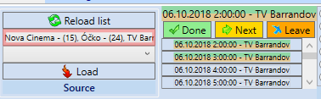

StreamsCollection

ActualStream

SourcesByMediums

Mediums = Sources.GroupBy(d => d.MediumName).Select(d => new MediumNameWrapper()

Mame SelectedSourceByMedium, Tlacitkem Load se dostanu do metody Confirm()

**Reseni** : opravil P Holubec

# Zachytávadlo - čas v okně přehrávání videa (split)

<https://tfs.mediaresearch.cz/AdIntel/AdIntel/_workitems/edit/50137>

Hash**5dddc5cc496246bbfaac6d5df9a2f6485fb7c6eb**

Prostředí **CZ test**

**Kroky:**

1. Otevřu si stream Disney Channel (23.9.2018 15:46, délka 00:29:29). Stream je zkrácený od začátku. <https://gyazo.com/e1aef6f7ac46bba876b378b7f1c6c9df>

2. 2x kliknu LTM na nějakou zachycenou MM: <https://gyazo.com/f3451ab60e963d02c1634ad4892aa6c4>

3. MM se mi označí ve framech červenými čísly. Začínají od 3. framu.

4. Kliknu na "Play vide..." v horním menu.

5. Podle "obrázků" vidím, že se mi to přehrává správně, ale časová osa je jinak: <https://gyazo.com/20b9317ecd66faa1036bfbb1db2c9e4f>

**Současné chování:**

Na časové ose videopřehrávače se zobrazí skutečná délka videa - 00:29:29:440 (viz bod 1). Čas přehrávání cca 00:07:44, tzn. 7 minut po začátku zpracované části videa. Zpracovaná část videa začíná po 46. minutě + 7 minut z videopřehrávače = čas zobrazované oblasti cca po 53. minutě. To odpovídá: <https://gyazo.com/0ee3efdd3373feef6325fb05cc9f932c>.

**Požadované chování:**

Chyba to vysloveně není, ale může to poplést uživatele. Ve videopřehrávači se ukazují hodnoty přepočítané k délce existujícího videa.

a) nechat to tak, jak je = výjimka pro split streamy

b) upravit to tak, že se bude zobrazovat čas podle přepočítané osy, tzn. 00:53:26:226/01:15:00:00 (časy podle příkladu <https://gyazo.com/0ee3efdd3373feef6325fb05cc9f932c>).

ten textblock v LightVidePlayerControl existuje: <TextBlock Text="{Binding ShiftedPosition}" />

Tato properta je zadefinovana v basovce LightVideoPlayerViewModel tedy PlayerBase.ShiftedPosition, ale zrejme se nikdy nenotifikuje UI a nebo je rozbitej binding.

F.

Zde je důkaz, to tak musí být „pozice upravená o shift“, M.

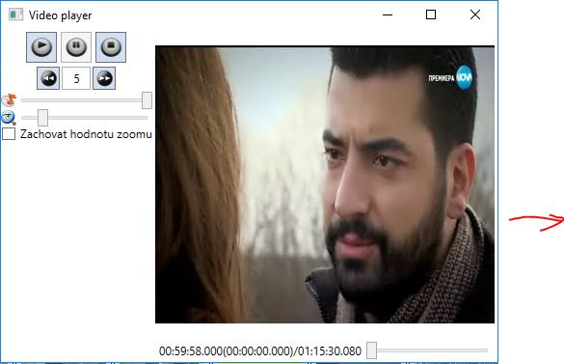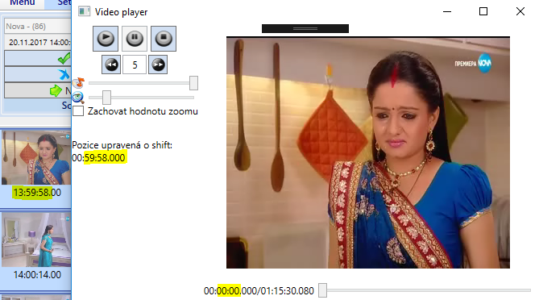

**PlaybackMenuGroupVM** ma VideoDialogViewModel : base(new LightVideoPlayerViewModel()

Svoji bazovce predava pri vytvoreni novou instanci LightVideoPlayerViewModelu. Tim ma tento Light dostupny v properte VideoPlayerViewModel.

public void PlayVideo()

{

DisplayWindow(ref m_videoWindow, d => d.PositionSeconds = m_streamPositionProvider.GetActualPosition() ?? 0d);

Viz take <https://d.docs.live.net/b22fb0fb09218bf0/Nielsen%20%20prace/Moje%20poznamky%20Nielsen/LightVideoPlayer.docx>

Rozdeleny split stream se streamem uprostred. Stream muze byt jen souvisly interval.

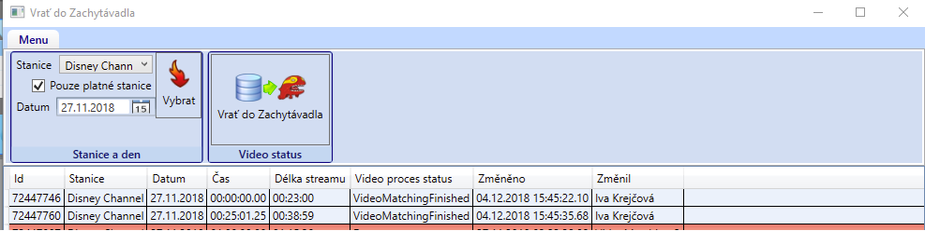



**Reseni:**

Musim upravit LightVideoPlayer ve Framework.Multimedia

Pridam do LVPControl.xaml:

<StackPanel x:Name="SplitPositionPanel">

<TextBlock Margin="5,2" Text="{x:Static resources1:Strings.SplitPosition}" />

<TextBlock

x:Name="SplitPositionTextBlock"

Margin="5,2"

Text="{Binding SplitPosition}" />

</StackPanel>

Do behindu:



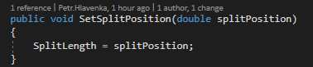

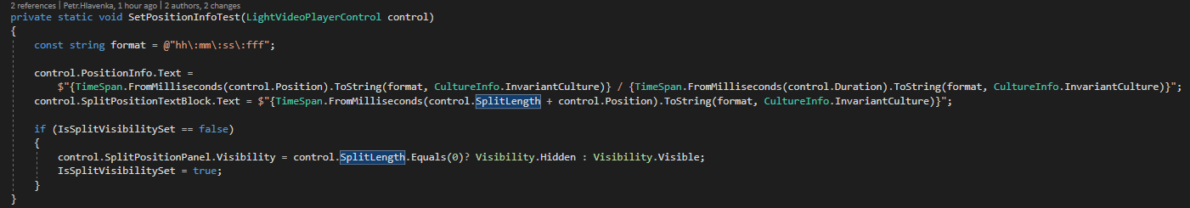

Do metody OnMediaOpenned:



LightVideoPlayerViewModel:

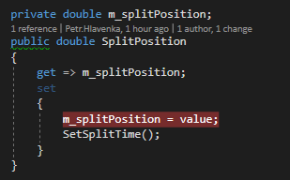

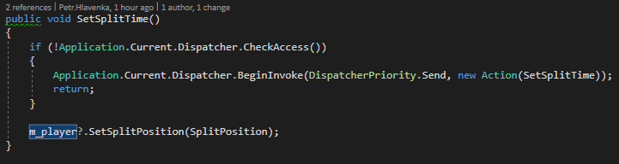

Zachytavadlo – ThumbnailStreamViewerViewModel:

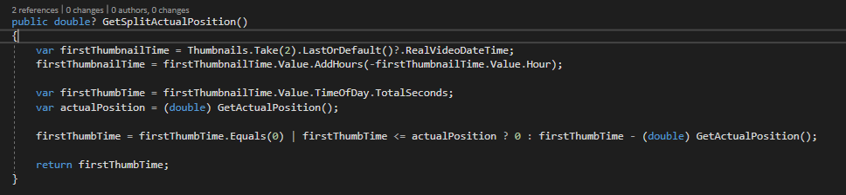

IstreamPositionProvider:



VideoDialogViewModel:

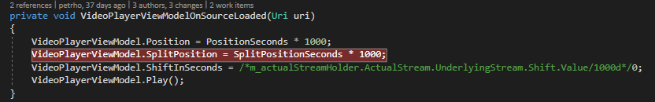

PlaybackMenuGroupViewModel:

